*Mr.Vinay kumar*

***DOS COMMANDS***

* **dir (directory) :-**  dir will show All The files & Folders in the location with details.

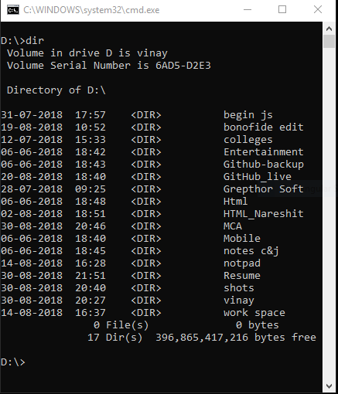

* **dir/p (directory/page wise) :-** dir will show All The files & Folders display with details page wise.

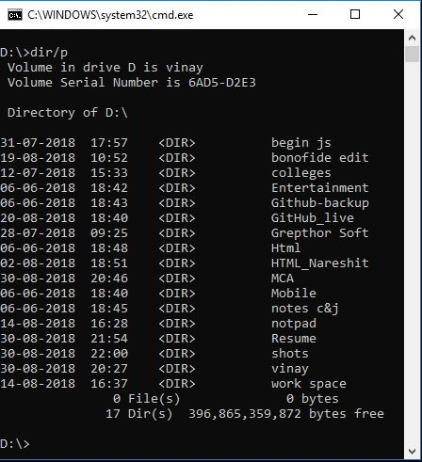

* **dir/w(directory/window) :-** dir/w will show All The files & Folders names only

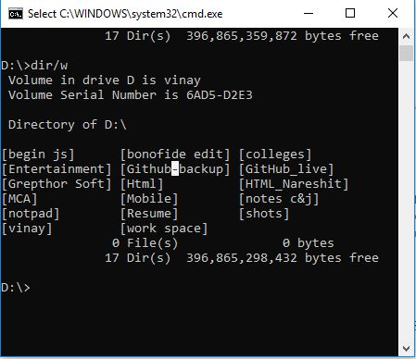

* **time :-** display the time based on user cpu time

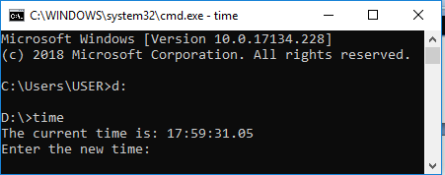

* **Date *:*-** display the time based on user cpu date

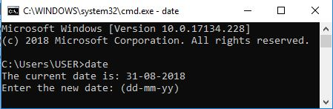

* **Cls(clear screen):-** it clear the screen

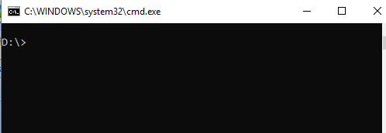

* **Move :-** move the file from one location to another folder

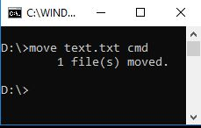

* **ren :-** if you want to rename a file from existing file then use this cmd

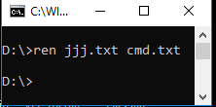

* **Create Text File :-** this command is used to create a new text file ie ***copy con filename.txt***

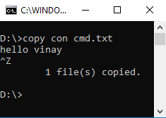

* **Ver :-** this command will show version of window what kind of version we use

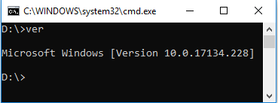

* **CD(change directory) :-**  this command is used to change the directory **cd filename**

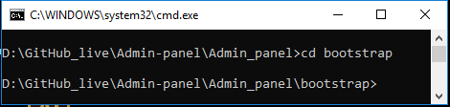

* **Cd .. :-** this command is used to goes back one directory

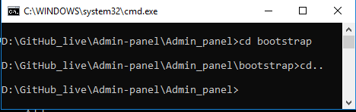

* **Cd ../../../ :-** this command is used to goes back as depends on couple of dotes(..) **cd ../../**

